SEQUENCING THROUGH TIME & PLACE:

THE CARISSA MINE

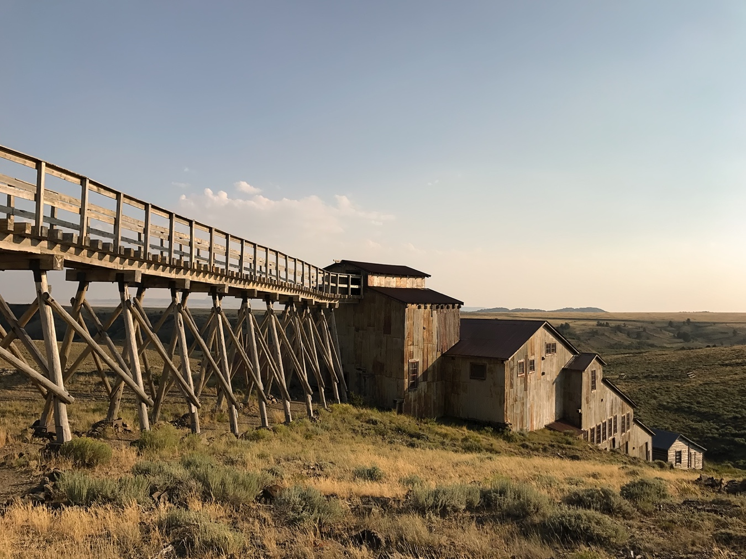
The Carissa Mine, South Pass City, 2017. Photo: Susan Moldenhauer

July 21 – September 1, 2018

Lander Art Center

Funded in part by the Friends of South Pass City and the Wyoming Arts Council
through the National Endowment for the Arts and the Wyoming State Legislature

SOUTH PASS CITY AND THE CARISSA MINE

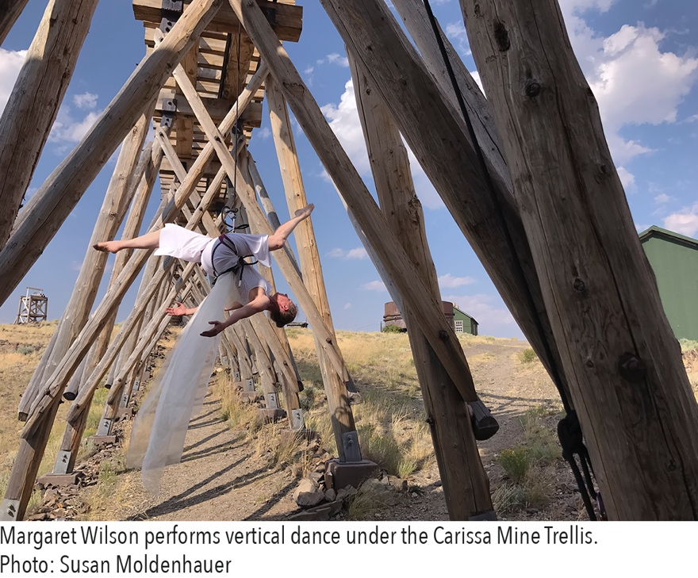
Founded in 1868, in Wyoming’s only gold rush, South Pass City and the Carissa Mine have a tumultuous history. The Carissa claim was filed by soldiers stationed at Fort Bridger in June of 1867. Prospecting was encouraged by the army and many soldiers had experience with gold mining from other booms throughout the United States. When the soldiers returned to their barracks, word of the discovery of gold spread quickly. By the spring of the following year, thousands of miners flocked to South Pass City from all corners of the United States. Prospect pits, ditches, tunnels, and mills rose overnight to accommodate the mining. Saloons, mercantiles, gaming houses and homes were built to entertain and house 2,000 miners. Just three years after the end of the Civil War, Union and Confederate soldiers warily labored together with pan and sluice box. Hope was the glue that held the peace. Some thrived, but for most, it did not last. By 1872 the surface gold began to deplete, and the precious metal was harder to pry from the ground.

Placer mining was replaced by underground mining at greater depth. Small mining operations were bought out by bigger concerns that didn’t need hundreds of employees, but instead relied on a hand-full of skilled individuals who could be more efficient at mining. By 1890 the population of the region numbered a few hundred. Capital from Eastern cities, and especially Chicago, still flowed into the Carissa. To keep production going, state-of-the-art mining and milling technology was freighted by the Union Pacific Rail Road, then by wagon teams 80 miles across the Red Desert. Entire gold mill buildings were shipped from the Northwest Coast. The Carissa saw three of these massive facilities built within 30 years, each larger and more complex than the next. With each modernization, operation costs skyrocketed, but the yield was just enough to cover costs. Eventually, the town of South Pass City slowly began to fall into ruin. Businesses and saloons sat empty. Homes built with optimism were sold as firewood. By the mid 1950’s the Carissa Mine was leased to smaller operations or sold to speculators hoping to flip the property. The Carissa came to the State of Wyoming in 2003.

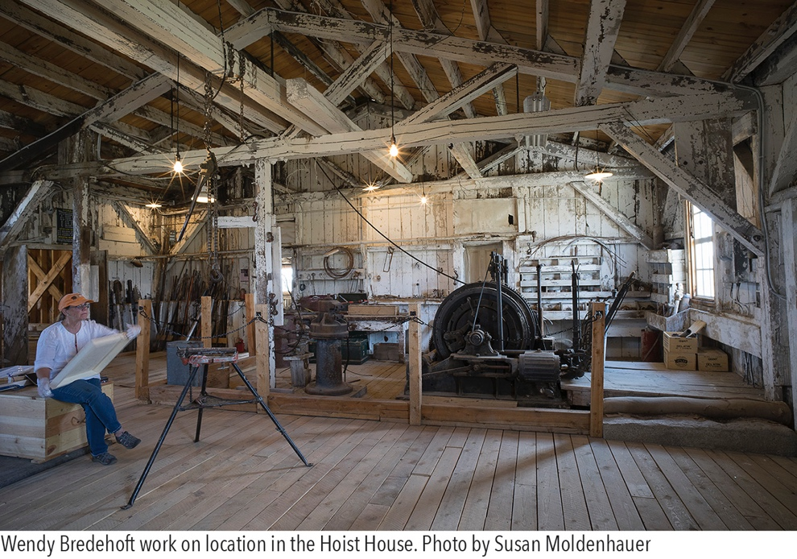
The buildings, artifacts and machinery that are left behind are more than a source of nostalgia or a fantasy of the wild West. It is a very physical record of human effort, a document of our aspirations to wealth, an image of our tenacity as well as the folly that sometimes comes with human effort. Since its creation as a state historic site South Pass City and the Carissa Mine has given the public the opportunity to directly, physically, experience these places and create their own memories.

It is fitting then to have the artists group – Sequencing Through Time & Place – Wendy Lemen Bredehoft, Susan Moldenhauer and Margaret Wilson – create art from their experiences at the Carissa Mine. Each artist’s creative process brings a new perspective to the Carissa and South Pass City. Through this exhibition, spaces that are traditionally viewed as places of work are seen for the beauty of construction, or the complexity of space. Memories of physical labor are translated into movement and dance. Surfaces and objects are enriched in an effort to capture the nuance of years of tactile use, followed by abandonment. We see the history of the Carissa in a new way, adding understanding, empathy, and beauty to the rich history of the Carissa Mine

South Pass City State Historic Site and the Friends of South Pass wish to thank Wendy Bredehoft, Susan Moldenhauer and Margaret Wilson for time and thought they have put into the project. We would also like to thank our partner exhibition spaces at the University of Wyoming Department of Art and Art History and the Lander Art Center.

Joe Ellis
Superintendent, South Pass City
May 2018

SEQUENCING THROUGH TIME & PLACE: THE CARISSA MINE

Wendy Lemen Bredehoft, Susan Moldenhauer, and Margaret Wilson – mixed media artist, photographer, and dancer – have been working together under the name Sequencing Through Time & Place since 2009. Their work explores the fundamentals of the creative process and how artists perceive, respond to and express place through different expressive lenses. They have worked side by side in Wyoming, London, Venice, and most recently at the Carissa Mine at the South Pass City State Historical Site in Central Wyoming.

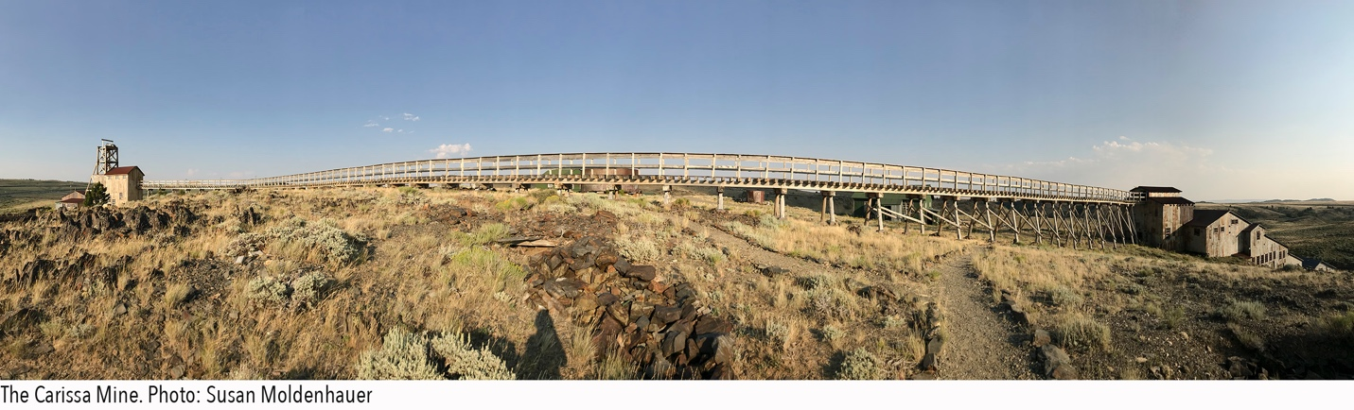

Sequencing Through Time & Place: The Carissa Mine presents a contemporary response to place through works that explore the physical, historical, and cultural aspects of the historic Carissa Mine through photography, dance and movement (video and performance), and mixed media. The exhibition concentrates on three sections of the mine: the smaller head or "hoist" house where ore was extracted and brought to the surface (the “white” or “light side"), the trestle for transporting the ore, and the mill house (or larger “dark side”) where gold was processed from the ore.

On location, we work side by side and apart. Our days are structured between working, meals and discussions. Once we were back in our respective studios to examine what imagery and ideas we captured and how to evolve that into final work, we realized through continuing discussions that several themes or ideas overlap at the Carissa: light and darkness, texture, architecture and machinery, repetitive structures and processes, the overwhelming sense of massive materials and toxic chemicals, moments of feeling the presence of others from another time, and the dominating sense of the human ingenuity and hard work.

We are fortunate to have two distinct exhibition spaces for this project, this one at the Lander Art Center and a second one at the University of Wyoming Visual Art Building Gallery. Each are developed for its specific gallery. A publication of combined work will be available at the end of the summer 2018.

New to our process is the introduction of a musical response to the exhibitions. We are so pleased to be working with Rod Garnett, UW professor emeritus in music, in this capacity. He will join Margaret Wilson in the performances that will be part of our receptions at both locations.

SEQUENCING THROUGH TIME & PLACE:
THE CARISSA MINE
University of Wyoming Visual Art Building Gallery
Through September 14, 2018
Closing Reception: September 7, 2018; 7 – 9 pm

PUBLICATION ORDERS
www.blurb.com/bookstore
ARTIST BACKGROUNDS

Wendy Bredehoft is a studio artist who explores the geographic, botanic, structural and atmospheric conditions of place through shape, texture, color, and space. She works in a variety of media, using materials as a means of exploring ideas and responding to place. She was the Education Curator for the University of Wyoming Art Museum, served as the Director of Cultural Resources for the State of Wyoming, and as the Arts Education Specialist for the Wyoming Arts Council. She is a recipient of an honorable mention for the 2016 Wyoming Visual Artist Fellowship, has a national exhibition record and is represented in numerous public and private collections.

Susan Moldenhauer retired from her role as director and chief curator of the University of Wyoming Art Museum in 2017. She has maintained a studio practice in photography since 1984 and has co-founded and been active in numerous community-based projects that advance the visibility of artists and public art in Laramie. She is a recipient of the 2017 Wyoming Governor’s Arts Award and a 2016 Wyoming Visual Artist Fellowship. Her studio practice is place-based and explores the synthesis of light, darkness, movement, and moment. She works in series which include musicians, panoramas, pinhole, and “views from home.” She has a national exhibition record and is represented in numerous public collections.

Margaret Wilson is a professor of Theatre & Dance at the University of Wyoming. She teaches all levels of modern dance technique, kinesiology, dance history, pedagogy and vertical dance. Her work is based on three approaches: movement exploration in a place (documented by video), “choreographing” video clips of work based on shared artistic themes, and live performance. These processes balance her interests in exploration with material documentation, the ephemeral “here and now” of movement creation with reflective and tangible composition, and the opportunity to transform the media into medium – in performance.

Collaborating Artists in The Carissa Mine Exhibitions

Rodney Garnett is professor emeritus in the University of Wyoming Department of Music, and has worked extensively as a free-lance musician in orchestras, jazz and chamber music ensembles, folk music ensembles, and recording studios. He is a recipient of the 2003 Wyoming Governor's Arts Award, the 2008 University of Wyoming Internationalization Award, and was the 2007 University of Wyoming Presidential Speaker. He continues to be an active performer and teacher, utilizing many styles and forms of flutes while collaborating with colleagues around the world to learn more about cultural improvisation and creativity among musicians in emergent social and material settings.

Leroy Hodgson is a scenic artist in the University of Wyoming Department of Theatre and Dance.

ACKNOWLEDGEMENTS

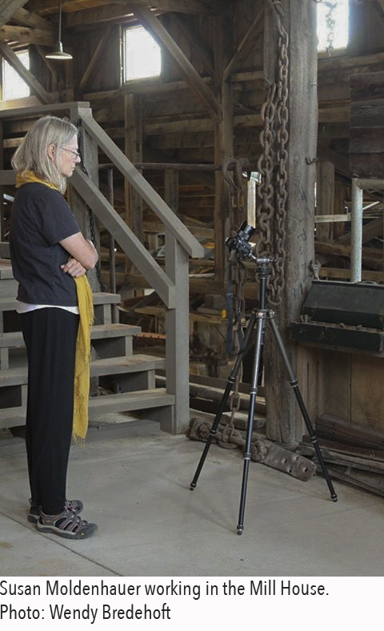
We are so excited to present our latest work in two different exhibitions in two locations this summer! There are many to thank for this opportunity, especially in conjunction with 150th anniversary celebrations across southern Wyoming this year.

A most special thanks to the Friends of South Pass City for funding a proposal for working on location and developing exhibitions based on the phenomenal Carissa Mine. Our time in the mine over the last two years has been most special. We are particularly honored to be the first artists to explore and respond to the mine, its history, architecture, and specialness of place. This would not have happened without the support and guidance of South Pass City’s Superintendent, Joe Ellis. Thank you for believing in us and supporting our interest in exploring the Carissa Mine in greater depth than our first two overnight visits!

We are excited to be able to think about our work together and contextualize it in two distinct exhibitions, one at the University of Wyoming and the other at the Lander Art Center. Thank you, Ricki Klages, Chair, UW Department of Art and Art History, and Stacy Stebner, Director, Lander Art Center for your interest in the Carissa Mine project. We offer a special note of acknowledgement to Rani Robison and David Jones of the University of Wyoming Visual Arts Building Gallery for your work with us in managing exhibition details and installation in Laramie. A special thank you to Leroy Hodson, UW Department of Theatre & Dance for the construction of the costume, Following the Vein, and to Neil Humphrey for assistance with videography and rigging for the vertical dance works.

For the first time, we have invited a composer and musician to be part of our collaborative project. We thank Rod Garnett, UW Professor Emeritus of Music for his interest and enthusiasm in taking on this challenge.

Our sincere thanks to the Wyoming Arts Council for individual project grants in support for this iteration of Sequencing Through Time & Place. Funds and support have made the presentation of the exhibitions possible.

ARTWORK AVAILABLE FOR PURCHASE
See Object Checklist for pricing information.

